天净沙系列 |  | CAT#:60908-3550  低温运输，-20℃ 保存 | 

pGBKT7质粒
pGBKT7 Plasmid
 |  | 图谱及序列
北京天恩泽基因科技有限公司
北京市海淀区上地信息路26号北京市留学人员海淀创业园中关村创业大厦506
网址：www.tiandz.com；电话：400-6765278；电邮：order@tiandz.com
产品及特点
  质粒名称 | pGBKT7
  质粒大小 | 7303 bp
  抗性 | 卡那霉素（Kanamycin）
  质粒类型 | 酵母表达/酵母双杂交载体
  是否病毒 | ---
  启动子 | ADH1
  稳转或瞬转 | ---
  组成型或诱导性 | ---
  表达水平 | 高
  载体标签 | c-Myc
  测序引物 | T7 Forward
规格及成分
  成分 | 产品编号 | 产品规格
  pGBKT7质粒DNA | 60908-3550 | 2 μg
  使用手册 | 1份
多克隆位点 | 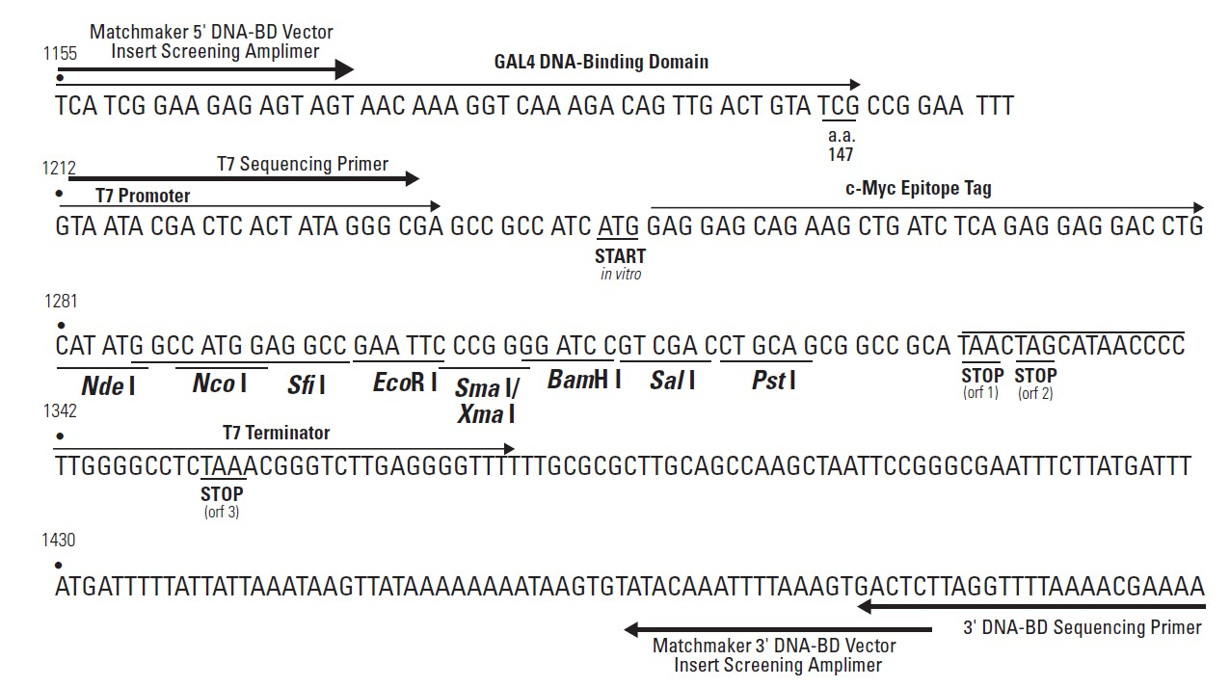
运输及保存 | 低温运输，-20℃保存，有效期一年。
使用方法 | 具体步骤请见分子克隆手册等工具书。
质粒图谱 | 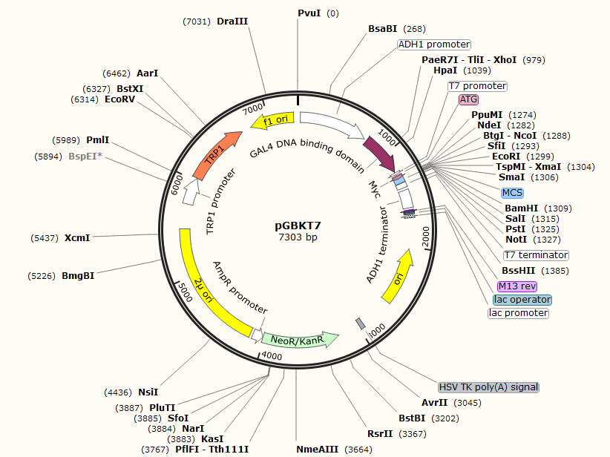
主要功能区
  名称 | 位置 | 长度(bp) | 类别
  ADH1 promoter | 30-734 | 705 | 启动子
  GAL4 DNA binding domain | 762-1202 | 441 | 编码区
  T7 promoter | 1213-1231 | 19 | 启动子
  ATG | 1245-1247 | 3 | 编码区
  Myc | 1251-1280 | 30 | 编码区
  MCS | 1281-1333 | 53 | misc_feature
  T7 terminator | 1338-1385 | 48 | 终止子
  ADH1 terminator | 1412-1599 | 188 | 终止子
  M13 rev | 1623-1639 | 17 | 引物结合区
  lac operator | 1647-1663 | 17 | 蛋白结合区
  lac promoter | 1671-1701 | 31 | 启动子
  ori | 2025-2613 | 589 | 复制起始区
  HSV TK poly(A) signal | 2942-2989 | 48 | misc_feature
  NeoR/KanR | 3221-4015 | 795 | 编码区
  AmpR promoter | 4016-4120 | 105 | 启动子
  2μ ori | 4147-5489 | 1343 | 复制起始区
  TRP1 promoter | 5748-6029 | 282 | 启动子
  TRP1 | 6030-6704 | 675 | 编码区
  f1 ori | 6807-7262 | 456 | 复制起始区
质粒序列 | 本序列电子版可从本公司网站www.tiandz.com下载  CGGTGCGGGCCTCTTCGCTATTACGCCAGATCCTTTTGTTGTTTCCGGGTGTACAATATGGACTTCCTCTTTTCTGGCAA  CCAAACCCATACATCGGGATTCCTATAATACCTTCGTTGGTCTCCCTAACATGTAGGTGGCGGAGGGGAGATATACAATA  GAACAGATACCAGACAAGACATAATGGGCTAAACAAGACTACACCAATTACACTGCCTCATTGATGGTGGTACATAACGA  ACTAATACTGTAGCCCTAGACTTGATAGCCATCATCATATCGAAGTTTCACTACCCTTTTTCCATTTGCCATCTATTGAA  GTAATAATAGGCGCATGCAACTTCTTTTCTTTTTTTTTCTTTTCTCTCTCCCCCGTTGTTGTCTCACCATATCCGCAATG  ACAAAAAAATGATGGAAGACACTAAAGGAAAAAATTAACGACAAAGACAGCACCAACAGATGTCGTTGTTCCAGAGCTGA  TGAGGGGTATCTCGAAGCACACGAAACTTTTTCCTTCCTTCATTCACGCACACTACTCTCTAATGAGCAACGGTATACGG  CCTTCCTTCCAGTTACTTGAATTTGAAATAAAAAAAAGTTTGCTGTCTTGCTATCAAGTATAAATAGACCTGCAATTATT  AATCTTTTGTTTCCTCGTCATTGTTCTCGTTCCCTTTCTTCCTTGTTTCTTTTTCTGCACAATATTTCAAGCTATACCAA  GCATACAATCAACTCCAAGCTTGAAGCAAGCCTCCTGAAAGATGAAGCTACTGTCTTCTATCGAACAAGCATGCGATATT  TGCCGACTTAAAAAGCTCAAGTGCTCCAAAGAAAAACCGAAGTGCGCCAAGTGTCTGAAGAACAACTGGGAGTGTCGCTA  CTCTCCCAAAACCAAAAGGTCTCCGCTGACTAGGGCACATCTGACAGAAGTGGAATCAAGGCTAGAAAGACTGGAACAGC  TATTTCTACTGATTTTTCCTCGAGAAGACCTTGACATGATTTTGAAAATGGATTCTTTACAGGATATAAAAGCATTGTTA  ACAGGATTATTTGTACAAGATAATGTGAATAAAGATGCCGTCACAGATAGATTGGCTTCAGTGGAGACTGATATGCCTCT  AACATTGAGACAGCATAGAATAAGTGCGACATCATCATCGGAAGAGAGTAGTAACAAAGGTCAAAGACAGTTGACTGTAT  CGCCGGAATTTGTAATACGACTCACTATAGGGCGAGCCGCCATCATGGAGGAGCAGAAGCTGATCTCAGAGGAGGACCTG  CATATGGCCATGGAGGCCGAATTCCCGGGGATCCGTCGACCTGCAGCGGCCGCATAACTAGCATAACCCCTTGGGGCCTC  TAAACGGGTCTTGAGGGGTTTTTTGCGCGCTTGCAGCCAAGCTAATTCCGGGCGAATTTCTTATGATTTATGATTTTTAT  TATTAAATAAGTTATAAAAAAAATAAGTGTATACAAATTTTAAAGTGACTCTTAGGTTTTAAAACGAAAATTCTTATTCT  TGAGTAACTCTTTCCTGTAGGTCAGGTTGCTTTCTCAGGTATAGCATGAGGTCGCTCTTATTGACCACACCTCTACCGGC  ATGCAAGCTTGGCGTAATCATGGTCATAGCTGTTTCCTGTGTGAAATTGTTATCCGCTCACAATTCCACACAACATACGA  GCCGGAAGCATAAAGTGTAAAGCCTGGGGTGCCTAATGAGTGAGCTAACTCACATTAATTGCGTTGCGCTCACTGCCCGC  TTTCCAGTCGGGAAACCTGTCGTGCCAGCTGCATTAATGAATCGGCCAACGCGCGGGGAGAGGCGGTTTGCGTATTGGGC  GCTCTTCCGCTTCCTCGCTCACTGACTCGCTGCGCTCGGTCGTTCGGCTGCGGCGAGCGGTATCAGCTCACTCAAAGGCG  GTAATACGGTTATCCACAGAATCAGGGGATAACGCAGGAAAGAACATGTGAGCAAAAGGCCAGCAAAAGGCCAGGAACCG  TAAAAAGGCCGCGTTGCTGGCGTTTTTCCATAGGCTCCGCCCCCCTGACGAGCATCACAAAAATCGACGCTCAAGTCAGA  GGTGGCGAAACCCGACAGGACTATAAAGATACCAGGCGTTTCCCCCTGGAAGCTCCCTCGTGCGCTCTCCTGTTCCGACC  CTGCCGCTTACCGGATACCTGTCCGCCTTTCTCCCTTCGGGAAGCGTGGCGCTTTCTCATAGCTCACGCTGTAGGTATCT  CAGTTCGGTGTAGGTCGTTCGCTCCAAGCTGGGCTGTGTGCACGAACCCCCCGTTCAGCCCGACCGCTGCGCCTTATCCG  GTAACTATCGTCTTGAGTCCAACCCGGTAAGACACGACTTATCGCCACTGGCAGCAGCCACTGGTAACAGGATTAGCAGA  GCGAGGTATGTAGGCGGTGCTACAGAGTTCTTGAAGTGGTGGCCTAACTACGGCTACACTAGAAGAACAGTATTTGGTAT  CTGCGCTCTGCTGAAGCCAGTTACCTTCGGAAAAAGAGTTGGTAGCTCTTGATCCGGCAAACAAACCACCGCTGGTAGCG  GTGGTTTTTTTGTTTGCAAGCAGCAGATTACGCGCAGAAAAAAAGGATCTCAAGAAGATCCTTTGATCTTTTCTACGGGG  TCTGACGCTCAGTGGAACGAAAACTCACGTTAAGGGATTTTGGTCATGAGATTATCAAAAAGGATCTTCACCTAGATCCT  TTTAAATTAAAAATGAAGTTTTAAATCAATCTAAAGTATATATGAGTAACCTGAGGCTATGGCAGGGCCTGCCGCCCCGA  CGTTGGCTGCGAGCCCTGGGCCTTCACCCGAACTTGGGGGGTGGGGTGGGGAAAAGGAAGAAACGCGGGCGTATTGGCCC  CAATGGGGTCTCGGTGGGGTATCGACAGAGTGCCAGCCCTGGGACCGAACCCCGCGTTTATGAACAAACGACCCAACACC  GTGCGTTTTATTCTGTCTTTTTATTGCCGTCATAGCGCGGGTTCCTTCCGGTATTGTCTCCTTCCGTGTTTCAGTTAGCC  TCCCCCTAGGGTGGGCGAAGAACTCCAGCATGAGATCCCCGCGCTGGAGGATCATCCAGCCGGCGTCCCGGAAAACGATT  CCGAAGCCCAACCTTTCATAGAAGGCGGCGGTGGAATCGAAATCTCGTGATGGCAGGTTGGGCGTCGCTTGGTCGGTCAT  TTCGAACCCCAGAGTCCCGCTCAGAAGAACTCGTCAAGAAGGCGATAGAAGGCGATGCGCTGCGAATCGGGAGCGGCGAT  ACCGTAAAGCACGAGGAAGCGGTCAGCCCATTCGCCGCCAAGCTCTTCAGCAATATCACGGGTAGCCAACGCTATGTCCT  GATAGCGGTCCGCCACACCCAGCCGGCCACAGTCGATGAATCCAGAAAAGCGGCCATTTTCCACCATGATATTCGGCAAG  CAGGCATCGCCATGAGTCACGACGAGATCCTCGCCGTCGGGCATGCTCGCCTTGAGCCTGGCGAACAGTTCGGCTGGCGC  GAGCCCCTGATGCTCTTCGTCCAGATCATCCTGATCGACAAGACCGGCTTCCATCCGAGTACGTGCTCGCTCGATGCGAT  GTTTCGCTTGGTGGTCGAATGGGCAGGTAGCCGGATCAAGCGTATGCAGCCGCCGCATTGCATCAGCCATGATGGATACT  TTCTCGGCAGGAGCAAGGTGAGATGACAGGAGATCCTGCCCCGGCACTTCGCCCAATAGCAGCCAGTCCCTTCCCGCTTC  AGTGACAACGTCGAGCACAGCTGCGCAAGGAACGCCCGTCGTGGCCAGCCACGATAGCCGCGCTGCCTCGTCTTGCAGTT  CATTCAGGGCACCGGACAGGTCGGTCTTGACAAAAAGAACCGGGCGCCCCTGCGCTGACAGCCGGAACACGGCGGCATCA  GAGCAGCCGATTGTCTGTTGTGCCCAGTCATAGCCGAATAGCCTCTCCACCCAAGCGGCCGGAGAACCTGCGTGCAATCC  ATCTTGTTCAATCATACTCTTCCTTTTTCAATATTATTGAAGCATTTATCAGGGTTATTGTCTCATGAGCGGATACATAT  TTGAATGTATTTAGAAAAATAAACAAATAGGGGTTCCGCGCACATTTCCCCGAAAAGTGCCACCTGAACGAAGCATCTGT  GCTTCATTTTGTAGAACAAAAATGCAACGCGAGAGCGCTAATTTTTCAAACAAAGAATCTGAGCTGCATTTTTACAGAAC  AGAAATGCAACGCGAAAGCGCTATTTTACCAACGAAGAATCTGTGCTTCATTTTTGTAAAACAAAAATGCAACGCGAGAG  CGCTAATTTTTCAAACAAAGAATCTGAGCTGCATTTTTACAGAACAGAAATGCAACGCGAGAGCGCTATTTTACCAACAA  AGAATCTATACTTCTTTTTTGTTCTACAAAAATGCATCCCGAGAGCGCTATTTTTCTAACAAAGCATCTTAGATTACTTT  TTTTCTCCTTTGTGCGCTCTATAATGCAGTCTCTTGATAACTTTTTGCACTGTAGGTCCGTTAAGGTTAGAAGAAGGCTA  CTTTGGTGTCTATTTTCTCTTCCATAAAAAAAGCCTGACTCCACTTCCCGCGTTTACTGATTACTAGCGAAGCTGCGGGT  GCATTTTTTCAAGATAAAGGCATCCCCGATTATATTCTATACCGATGTGGATTGCGCATACTTTGTGAACAGAAAGTGAT  AGCGTTGATGATTCTTCATTGGTCAGAAAATTATGAACGGTTTCTTCTATTTTGTCTCTATATACTACGTATAGGAAATG  TTTACATTTTCGTATTGTTTTCGATTCACTCTATGAATAGTTCTTACTACAATTTTTTTGTCTAAAGAGTAATACTAGAG  ATAAACATAAAAAATGTAGAGGTCGAGTTTAGATGCAAGTTCAAGGAGCGAAAGGTGGATGGGTAGGTTATATAGGGATA  TAGCACAGAGATATATAGCAAAGAGATACTTTTGAGCAATGTTTGTGGAAGCGGTATTCGCAATATTTTAGTAGCTCGTT  ACAGTCCGGTGCGTTTTTGGTTTTTTGAAAGTGCGTCTTCAGAGCGCTTTTGGTTTTCAAAAGCGCTCTGAAGTTCCTAT  ACTTTCTAGAGAATAGGAACTTCGGAATAGGAACTTCAAAGCGTTTCCGAAAACGAGCGCTTCCGAAAATGCAACGCGAG  CTGCGCACATACAGCTCACTGTTCACGTCGCACCTATATCTGCGTGTTGCCTGTATATATATATACATGAGAAGAACGGC  ATAGTGCGTGTTTATGCTTAAATGCGTACTTATATGCGTCTATTTATGTAGGATGAAAGGTAGTCTAGTACCTCCTGTGA  TATTATCCCATTCCATGCGGGGTATCGTATGCTTCCTTCAGCACTACCCTTTAGCTGTTCTATATGCTGCCACTCCTCAA  TTGGATTAGTCTCATCCTTCAATGCTATCATTTCCTTTGATATTGGATCATACTAAGAAACCATTATTATCATGACATTA  ACCTATAAAAATAGGCGTATCACGAGGCCCTTTCGTCTCGCGCGTTTCGGTGATGACGGTGAAAACCTCTGACACATGCA  GCTCCCGGAGACGGTCACAGCTTGTCTGTAAGCGGATGCCGGGAGCAGACAAGCCCGTCAGGGCGCGTCAGCGGGTGTTG  GCGGGTGTCGGGGCTGGCTTAACTATGCGGCATCAGAGCAGATTGTACTGAGAGTGCACCATAGATCAACGACATTACTA  TATATATAATATAGGAAGCATTTAATAGAACAGCATCGTAATATATGTGTACTTTGCAGTTATGACGCCAGATGGCAGTA  GTGGAAGATATTCTTTATTGAAAAATAGCTTGTCACCTTACGTACAATCTTGATCCGGAGCTTTTCTTTTTTTGCCGATT  AAGAATTAATTCGGTCGAAAAAAGAAAAGGAGAGGGCCAAGAGGGAGGGCATTGGTGACTATTGAGCACGTGAGTATACG  TGATTAAGCACACAAAGGCAGCTTGGAGTATGTCTGTTATTAATTTCACAGGTAGTTCTGGTCCATTGGTGAAAGTTTGC  GGCTTGCAGAGCACAGAGGCCGCAGAATGTGCTCTAGATTCCGATGCTGACTTGCTGGGTATTATATGTGTGCCCAATAG  AAAGAGAACAATTGACCCGGTTATTGCAAGGAAAATTTCAAGTCTTGTAAAAGCATATAAAAATAGTTCAGGCACTCCGA  AATACTTGGTTGGCGTGTTTCGTAATCAACCTAAGGAGGATGTTTTGGCTCTGGTCAATGATTACGGCATTGATATCGTC  CAACTGCATGGAGATGAGTCGTGGCAAGAATACCAAGAGTTCCTCGGTTTGCCAGTTATTAAAAGACTCGTATTTCCAAA  AGACTGCAACATACTACTCAGTGCAGCTTCACAGAAACCTCATTCGTTTATTCCCTTGTTTGATTCAGAAGCAGGTGGGA  CAGGTGAACTTTTGGATTGGAACTCGATTTCTGACTGGGTTGGAAGGCAAGAGAGCCCCGAAAGCTTACATTTTATGTTA  GCTGGTGGACTGACGCCAGAAAATGTTGGTGATGCGCTTAGATTAAATGGCGTTATTGGTGTTGATGTAAGCGGAGGTGT  GGAGACAAATGGTGTAAAAGACTCTAACAAAATAGCAAATTTCGTCAAAAATGCTAAGAAATAGGTTATTACTGAGTAGT  ATTTATTTAAGTATTGTTTGTGCACTTGCCGATCTATGCGGTGTGAAATACCGCACAGATGCGTAAGGAGAAAATACCGC  ATCAGGAAATTGTAAGCGTTAATATTTTGTTAAAATTCGCGTTAAATTTTTGTTAAATCAGCTCATTTTTTAACCAATAG  GCCGAAATCGGCAAAATCCCTTATAAATCAAAAGAATAGACCGAGATAGGGTTGAGTGTTGTTCCAGTTTGGAACAAGAG  TCCACTATTAAAGAACGTGGACTCCAACGTCAAAGGGCGAAAAACCGTCTATCAGGGCGATGGCCCACTACGTGAACCAT  CACCCTAATCAAGTTTTTTGGGGTCGAGGTGCCGTAAAGCACTAAATCGGAACCCTAAAGGGAGCCCCCGATTTAGAGCT  TGACGGGGAAAGCCGGCGAACGTGGCGAGAAAGGAAGGGAAGAAAGCGAAAGGAGCGGGCGCTAGGGCGCTGGCAAGTGT  AGCGGTCACGCTGCGCGTAACCACCACACCCGCCGCGCTTAATGCGCCGCTACAGGGCGCGTCCATTCGCCATTCAGGCT  GCGCAACTGTTGGGAAGGGCGAT
20140905YZH

